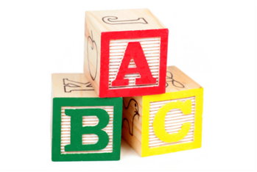BARCOMBE PLAYGROUP

Behaviour Management Policy

Our aim at Barcombe Playgroup is to provide an environment where children have happy, stimulating lives thus preventing them feeling the need to behave inappropriately. To this end we will:

- Praise children for good behaviour on a regular basis.

- Model good behaviour by treating children and adults around us with respect.

- Provide interesting and stimulating activities within a child friendly environment thus preventing children from becoming bored and irritable.

- Observe children closely and use our weekly planning to provide for their individual needs.

- Work closely with parents to support children’s exploration of appropriate and inappropriate behaviour.

If children behave in a consistently inappropriate manner e.g. hurting other children, verbally abusing children or staff, destroying play equipment, then we will:

- Use our observations to try to pinpoint trigger points and to improve our environment if appropriate.

- Help children who find it difficult to get on with others by showing them how to play and be friendly with other children.

- Give the child more one to one time in which they may be able to explain why they are behaving in this way.

- After consultation with parents, use a time out system for children aged over 2 years, of between 2 and 5 minutes when they will be removed from the play area to a quiet area. During this time the child’s key person will explain why they have been taken away from the play area. This system will be used consistently by all staff. Children under two years of age will be distracted from any situation which the staff feel is a problem and supported to join in more appropriate activities.

Where this does not result in an improvement of behaviour we will ask parents for permission to seek outside help.

If, after consultation with the parents/carers, we feel the child may have a Special Educational Need, we will follow our Policy on Special Educational Needs and Disability.

Staff at this nursery will not use corporal punishment or any other punishment which physically hurts the child or may humiliate them. Nor will they threaten to do so.

Physical intervention will only be used to manage a child’s behaviour if it is necessary to prevent personal injury to the child, other children or an adult, to prevent serious damage to property, or in what would reasonably be regarded as exceptional circumstances. Any occasion where physical intervention is used to manage a child’s behaviour will be recorded and parents will be informed about it on the same day or as soon as is reasonably practicable.

Biting
Many children go through a stage of biting other children and adults. We know this is an emotive subject and when this occurs, particularly if a child bites regularly, the following procedure will be followed:
The victim will be comforted by their key person and any required medical treatment given.
The perpetrator will be taken from the play area and told, in a manner appropriate to the child’s age that the behaviour was unacceptable. The child will not be shouted at and only one member of staff, preferably the child’s key person will deal with this.

Sanctions will be applied as stated in the behaviour management policy.
Staff will use their written observations and knowledge of the child to try to pinpoint trigger points and reasons.
The incident will be reported in the accident book
Parents of both children will be informed.

Parents of the victim will not be told the name of the perpetrator.

